3G150M-How to upgrade the firmware?
Product line: 3G Question category: Function configurations

Q: Why we need to upgrade firmware for the router?
A: Sometimes we may need to Upgrade the router to another firmware version if the current firmware version can no longer satisfies your requirement. For example, the new firmware will be of great valve to fix some bugs and to achieve better service.

The topology is as below
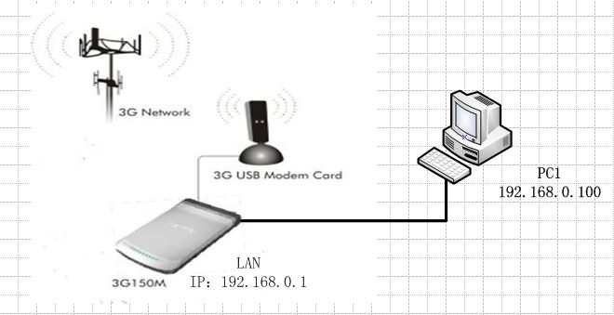
Warning:
1. Upgrade with Ethernet cable, do not upgrade wirelessly, it may cause failure and damage the router.
2. Do not Power off the router when upgrading
3. Do not upgrade remotely, please just directly connect your PC and router and perform the upgrade.
4. Please make sure you upgrade into a right firmware version. Wrong updates will damage your router.

Steps are as following:
- Download the correct firmware from our website www.tendacn.com to your computer. If you are not sure, please contact us.
- Please connect your computer to the RJ-45 port of the router with an Ethernet cable.
- Login the management page of the router. (The default login IP is 192.168.0.1, username and password both are admin).
4. Click System Tools->Upgrade on the left side, then click Browse to Locate and select the firmware, then click Upgrade to upgrade the firmware for the router. The router will reboot after finish upgrading.
